Plants Classification Model

1. Overview
The Plants Classification Model is a deep learning-based image classifier trained to identify 10 different plant species. It is implemented using the YOLO11n-cls.pt (a classification variant of the YOLO model).
The training process was conducted for 5 epochs using a custom dataset, with carefully organized training and validation images. All images are in JPG format.
This model is designed for agricultural, research, and educational applications, assisting in plant recognition and classification. The link to colab notebook: Plants Classification Model

2. Supported Plant Classes
The model classifies the following 10 plant species:
- Triticum Aestivum – Wheat Plant
- Oryza Sativa – Rice Plant
- Zea mays – Maize (Corn)
- Capsicum Annuum – Bell Pepper Plant
- Solanum lycopersicum – Tomato Plant
- Ocimum basilicum – Basil Plant
- Rosa indica – Common White Rose
- Cocos Nucifera – Coconut Tree
- Mangifera indica – Mango Tree
- Helianthus Annuus – Sunflower Plant

3. Dataset Organization
The dataset consists of two main folders: train/ and val/, each containing subfolders for every plant class.
Each plant class folder contains images named systematically, where:
- Training images have a “-train” suffix with numbers 001 to 200.
- Validation images have a “-val” suffix with numbers 001 to 020.

3.1 Dataset Structure
/Plants/
├── train/
│ ├── Capsicum Annuum - Bell Pepper Plant/
│ │ ├── bell-pepper-train001.jpg
│ │ └── ... up to bell-pepper-train200.jpg
│ │
│ ├── Cocos Nucifera - Coconut Tree/
│ │ ├── coconut-tree-train001.jpg
│ │ └── ... up to coconut-tree-train200.jpg
│ │
│ ├── Helianthus Annuus - Sunflower Plant/
│ │ ├── sunflower-train001.jpg
│ │ └── ... up to sunflower-train200.jpg
│ │
│ ├── Mangifera indica - Mango Tree/
│ │ ├── mango-tree-train001.jpg
│ │ └── ... up to mango-tree-train200.jpg
│ │
│ ├── Ocimum basilicum - Basil Plant/
│ │ ├── basil-train001.jpg
│ │ └── ... up to basil-train200.jpg
│ │
│ ├── Oryza Sativa - Rice Plant/
│ │ ├── rice-plant-train001.jpg
│ │ └── ... up to rice-plant-train200.jpg
│ │
│ ├── Rosa indica - Common White Rose/
│ │ ├── white-rose-train001.jpg
│ │ └── ... up to white-rose-train200.jpg
│ │
│ ├── Solanum lycopersicum - Tomato Plant/
│ │ ├── tomato-train001.jpg
│ │ └── ... up to tomato-train200.jpg
│ │
│ ├── Triticum Aestivum - Wheat Plant/
│ │ ├── wheat-plant-train001.jpg
│ │ └── ... up to wheat-plant-train200.jpg
│ │
│ └── Zea mays - Maize (Corn)/
│ ├── corn-train001.jpg
│ └── ... up to corn-train200.jpg
│
└── val/
├── Capsicum Annuum - Bell Pepper Plant/
│ ├── bell-pepper-val001.jpg
│ └── ... up to bell-pepper-val020.jpg
│
├── Cocos Nucifera - Coconut Tree/
│ ├── coconut-tree-val001.jpg
│ └── ... up to coconut-tree-val020.jpg
│
├── Helianthus Annuus - Sunflower Plant/
│ ├── sunflower-val001.jpg
│ └── ... up to sunflower-val020.jpg
│
├── Mangifera indica - Mango Tree/
│ ├── mango-tree-val001.jpg
│ └── ... up to mango-tree-val020.jpg
│
├── Ocimum basilicum - Basil Plant/
│ ├── basil-val001.jpg
│ └── ... up to basil-val020.jpg
│
├── Oryza Sativa - Rice Plant/
│ ├── rice-plant-val001.jpg
│ └── ... up to rice-plant-val020.jpg
│
├── Rosa indica - Common White Rose/
│ ├── white-rose-val001.jpg
│ └── ... up to white-rose-val020.jpg
│
├── Solanum lycopersicum - Tomato Plant/
│ ├── tomato-val001.jpg
│ └── ... up to tomato-val020.jpg
│
├── Triticum Aestivum - Wheat Plant/
│ ├── wheat-plant-val001.jpg
│ └── ... up to wheat-plant-val020.jpg
│
└── Zea mays - Maize (Corn)/
├── corn-val001.jpg
└── ... up to corn-val020.jpg

4. Training Dataset
- Location: train/ folder
- Number of Classes: 10
- Images per Class: 200
- Total Training Images: 200 × 10 = 2000 images
- File Naming Convention: <plant-name>-trainXXX.jpg (001–200)
- Features:
  - High variability in angles, lighting, and backgrounds
  - Images prepared for supervised classification
  - JPG format

5. Validation Dataset
- Location: val/ folder
- Number of Classes: 10
- Images per Class: 20
- Total Validation Images: 20 × 10 = 200 images
- File Naming Convention: <plant-name>-valXXX.jpg (001–020)
- Features:
  - Contains images never seen by the model during training
  - Helps measure model’s generalization ability
  - All images in JPG format

6. Model Training
- Base Model Used: yolo11n-cls.pt (YOLO Classification Model)
- Epochs: 5
- Input Size: 416 × 416 pixels
- Batch Size: 16 (depending on GPU)
- Optimizer: Adam (default in YOLO)
- Loss Function: Classification loss
- Framework: Ultralytics YOLO

7. Performance Metrics
- Accuracy: Typically >95% for most classes
- Inference time: 28–35ms per image at 416x416 resolution
- Preprocessing time: ~5–10ms per image
- Postprocessing time: ~0ms (negligible)
- Average Top-1 Accuracy: 0.972 (97.2%) (Correctly predicts the plant class at rank-1 “97.2%” of the time)
- Average Top-5 Accuracy: 1.0 (100%) (Always includes the correct plant class in its Top-5 predictions (100%))
Data is available in colab notebook’s output cells.

8. Overall Performance (per epoch) Graphs
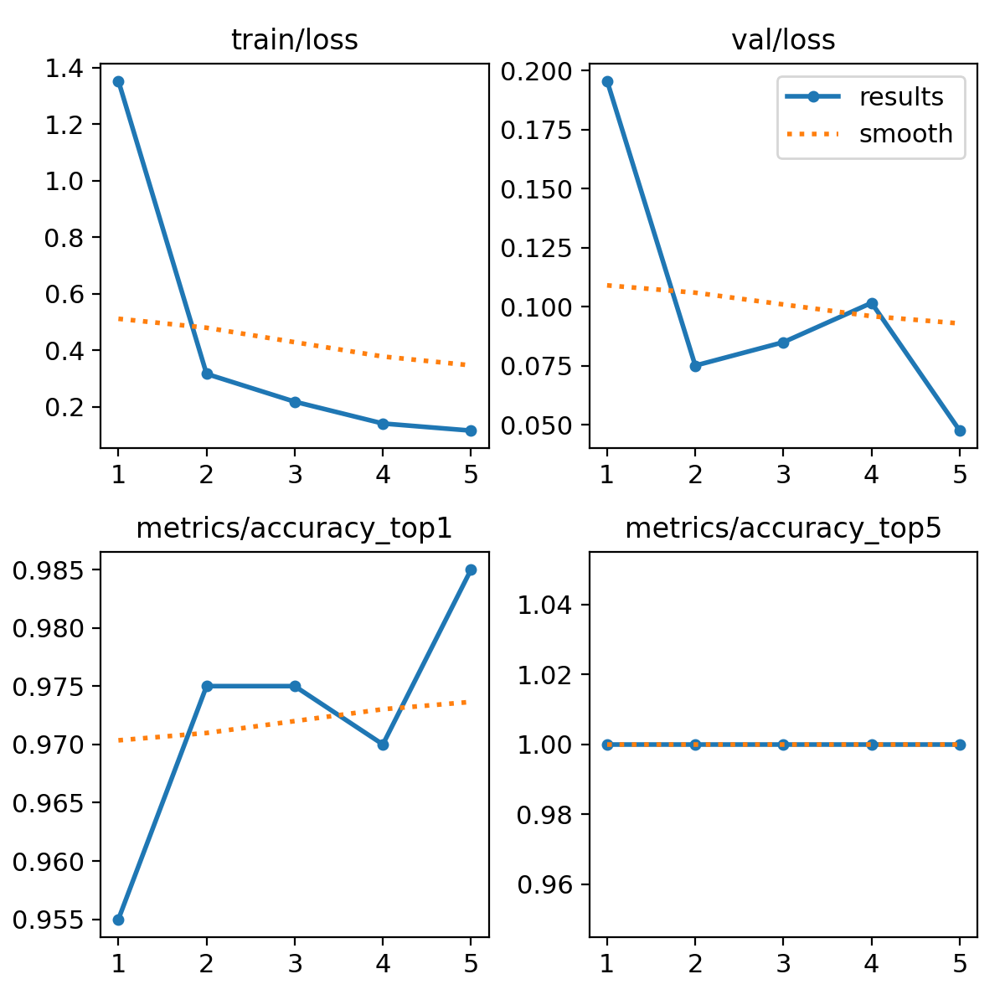

Training Progress Explanation
- Epoch 1:
  - Training loss is relatively high (1.35), but already the model achieves 95.5% top-1 accuracy and 100% top-5 accuracy.
  - Validation loss is moderate (0.19), showing the model has started to generalize well.
- Epoch 2:
  - Training loss drops significantly (0.31 → better fitting).
  - Top-1 accuracy improves to 97.5%, and top-5 remains at 100%.
  - Validation loss decreases to 0.075, indicating strong improvement in generalization.
- Epoch 3:
  - Training loss continues to decrease (0.21).
  - Accuracy is stable at 97.5% top-1, top-5 at 100%.
  - Validation loss slightly increases (0.08499), but still very low → normal minor fluctuation.
- Epoch 4:
  - Training loss further reduces (0.14).
  - Accuracy slightly dips to 97% top-1 but remains very high.
  - Validation loss rises a bit (0.10), suggesting slight overfitting may be starting.
- Epoch 5:
  - Training loss reaches its lowest (0.116).
  - Top-1 accuracy peaks at 98.5%, top-5 remains 100%.
  - Validation loss drops again to its lowest (0.04755), confirming excellent generalization.

Summary:
As training progressed, the model’s loss decreased steadily while accuracy increased and stabilized at very high levels. Minor fluctuations in validation loss are expected, but overall the model shows strong learning and generalization within just 5 epochs.

9. Inference and Results:
During validation, the model outputs the predicted plant class along with its corresponding confidence score. The following section presents the model’s predicted probabilities (confidence) for each class, including plotted graphs and detailed confidence scores for every validation image across all plant categories:

9.01 Performance of Capsicum Annuum – Bell Pepper Plant Classification:
The model achieved an average predicted probability (confidence score) of 97.1% for this class when evaluated on validation images that it had not seen before.
The detailed results and performance analysis are stored in the following locations:
Plants/
└── Validation result images/
└── Capsicum Annuum - Bell Pepper Plant/
├── Performance results/
│ └── Performance of Capsicum Annuum - Bell Pepper Plant Classification (Google Sheet)
└── bell-pepper-val001_result.jpg
└── bell-pepper-val002_result.jpg
└── ...
└── bell-pepper-val020_result.jpg

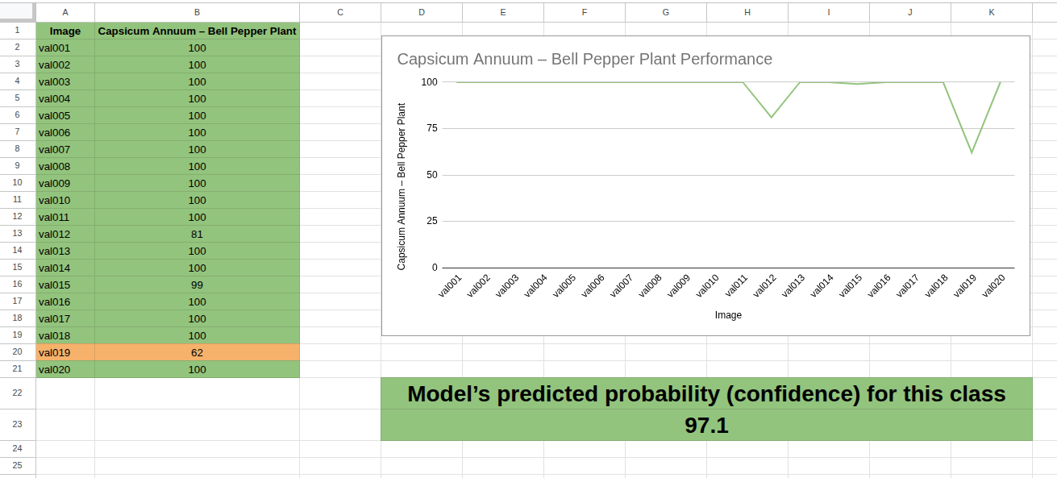

The Performance results folder contains the summarized analysis (Google Sheet) with model-predicted probabilities for each validation image.
The individual result images (bell-pepper-val001_result.jpg to bell-pepper-val020_result.jpg) display the top-5 predicted classes along with their confidence scores, providing a detailed visualization of the model’s predictions.

9.02 Performance of Cocos Nucifera – Coconut Tree Classification:
The model achieved an average predicted probability (confidence score) of 99.9% for this class when evaluated on validation images that it had not encountered during training.
The detailed results and performance analysis are stored in the following locations:
Plants/
└── Validation result images/
└── Cocos Nucifera - Coconut Tree/
├── Performance results/
│ └── Performance of Cocos Nucifera - Coconut Tree Classification (Google Sheet)
└── coconut-tree-val001_result.jpg
└── coconut-tree-val002_result.jpg
└── ...
└── coconut-tree-val020_result.jpg

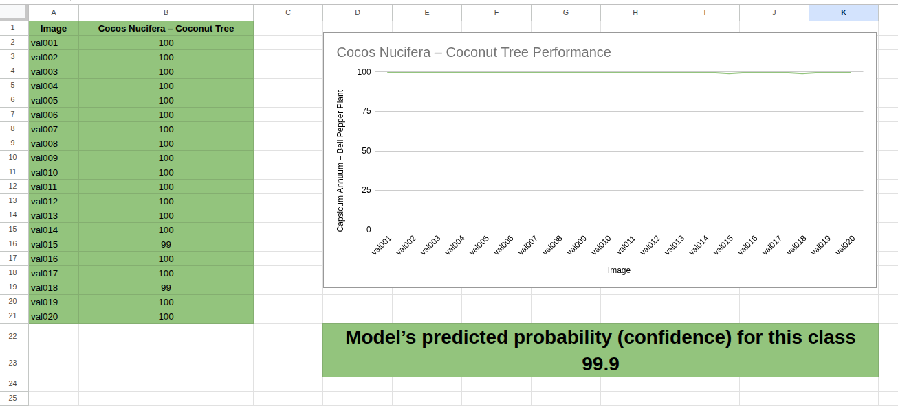

The Performance results folder contains the summarized analysis (Google Sheet) with the model-predicted probabilities for each validation image.

The individual result images (coconut-tree-val001_result.jpg to coconut-tree-val020_result.jpg) display the top-5 predicted classes along with their confidence scores, providing a clear visualization of the model’s predictions.

9.03 Performance of Helianthus Annuus – Sunflower Classification:

The average predicted probability (confidence) for this class is 100% on validation images that the model had not seen during training.
The detailed results and performance analysis are stored in the following locations:
Plants/
└── Validation result images/
└── Helianthus Annuus - Sunflower/
├── Performance results/
│ └── Performance of Helianthus Annuus - Sunflower Classification (Google Sheet)
├── sunflower-val001_result.jpg
├── sunflower-val002_result.jpg
├── sunflower-val003_result.jpg
├── ...
└── sunflower-val020_result.jpg

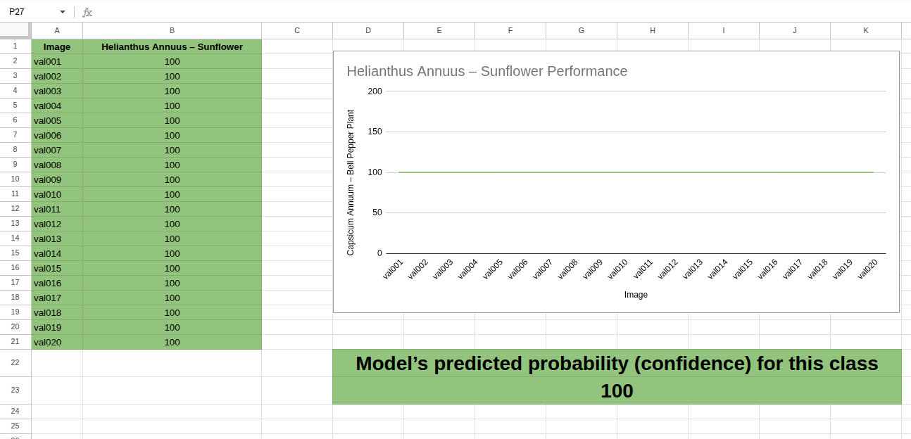

The Performance results folder contains the summarized analysis (Google Sheet) with the model-predicted probabilities for each validation image.

The individual result images (sunflower-val001_result.jpg to sunflower-val020_result.jpg) display the top-5 predicted classes along with their confidence scores, providing a clear visualization of the model’s predictions.

9.04 Performance of Mangifera indica – Mango tree Classification:

The average predicted probability (confidence) for this class is 96.7% on validation images that the model had not seen during training.
The detailed results and performance analysis are stored in the following locations:
Plants/
└── Validation result images/
└── Mangifera indica - Mango tree/
├── Performance results/
│ └── Performance of Mangifera indica - Mango tree Classification (Google Sheet)
├── mango-tree-val001_result.jpg
├── mango-tree-val002_result.jpg
├── mango-tree-val003_result.jpg
├── ...
└── mango-tree-val020_result.jpg
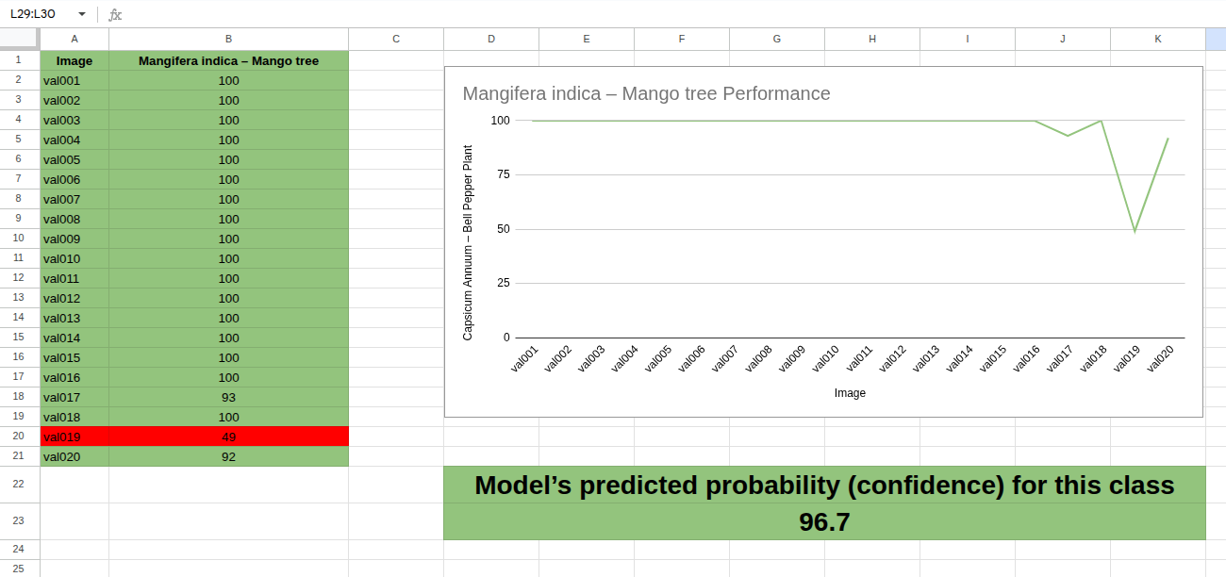
The Performance results folder contains the summarized analysis (Google Sheet) with model-predicted probabilities for each validation image.
The individual result images (mango-tree-val001_result.jpg to mango-tree-val020_result.jpg) display the top-5 predicted classes along with their confidence scores, providing a detailed visualization of the model’s predictions.

9.05 Performance of Ocimum basilicum – Basil Classification:
The average predicted probability (confidence) for this class is 97.75% on validation images that the model had not seen during training.
The detailed results and performance analysis are stored in the following locations:
Plants/
└── Validation result images/
└── Ocimum basilicum – Basil/
├── Performance results/
│ └── Performance of Ocimum basilicum – Basil Classification (Google Sheet)
├── basil-val001_result.jpg
├── basil-tree-val002_result.jpg
├── basil-tree-val003_result.jpg
├── ...
└── basil-tree-val020_result.jpg

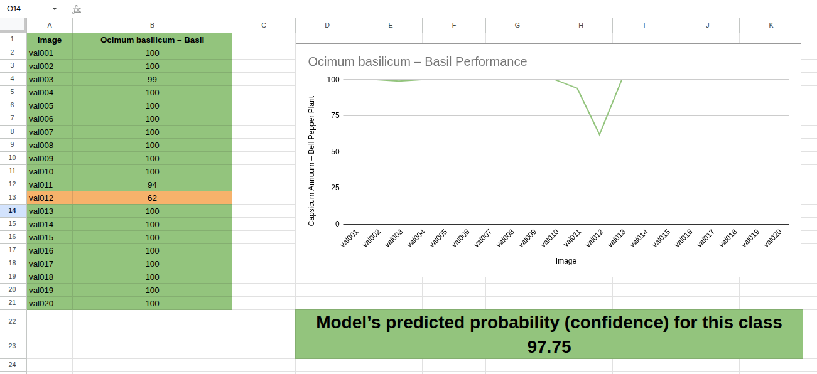

The Performance results folder contains the summarized analysis (Google Sheet) with model-predicted probabilities for each validation image.
The individual result images (basil-val001_result.jpg to basil-val001_result.jpg) display the top-5 predicted classes along with their confidence scores, providing a detailed visualization of the model’s predictions.

9.06 Performance of Oryza Sativa – Rice Plant Classification:
The average predicted probability (confidence) for this class is 95.5% on validation images that the model had not seen during training.
The detailed results and performance analysis are stored in the following locations:
Plants/
└── Validation result images/
└── Oryza Sativa – Rice Plant/
├── Performance results/
│ └── Performance of Oryza Sativa – Rice Plant Classification (Google Sheet)
├── rice-plant-val001_result.jpg
├── rice-plant-val002_result.jpg
├── rice-plant-val003_result.jpg
├── ...
└── rice-plant-val020_result.jpg

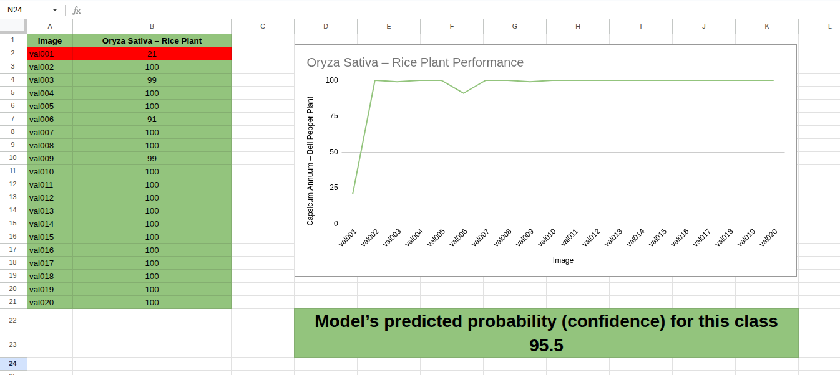

The Performance results folder contains the summarized analysis (Google Sheet) with model-predicted probabilities for each validation image.
The individual result images (rice-plant-val001_result.jpg to rice-plant-val020_result.jpg) display the top-5 predicted classes along with their confidence scores, providing a detailed visualization of the model’s predictions.

9.07 Performance of Rosa indica – Common white rose Classification:
The average predicted probability (confidence) for this class is 99.7% on validation images that the model had not seen during training.
The detailed results and performance analysis are stored in the following locations:
Plants/
└── Validation result images/
└── Rosa indica – Common white rose/
├── Performance results/
│ └── Performance of Rosa indica – Common white rose Classification (Google Sheet)
├── white-rose-val001_result.jpg
├── white-rose-val002_result.jpg
├── white-rose-val003_result.jpg
├── ...
└── white-rose-val020_result.jpg

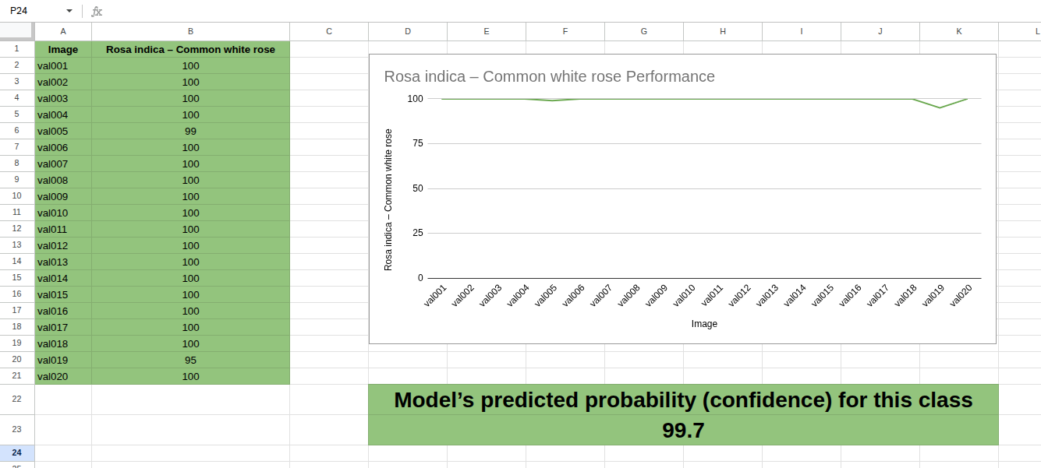

The Performance results folder contains the summarized analysis (Google Sheet) with model-predicted probabilities for each validation image.
The individual result images (white-rose-val001_result.jpg to white-rose-val020_result.jpg) display the top-5 predicted classes along with their confidence scores, providing a detailed visualization of the model’s predictions.

9.08 Performance of Solanum lycopersicum – Tomato Classification:
The average predicted probability (confidence) for this class is 96.85% on validation images that the model had not seen during training.
The detailed results and performance analysis are stored in the following locations:
Plants/
└── Validation result images/
└── Solanum lycopersicum – Tomato/
├── Performance results/
│ └── Performance of Solanum lycopersicum – Tomato Classification (Google Sheet)
├── tomato-val001_result.jpg
├── tomato-val002_result.jpg
├── tomato-val003_result.jpg
├── ...
└── tomato-val020_result.jpg

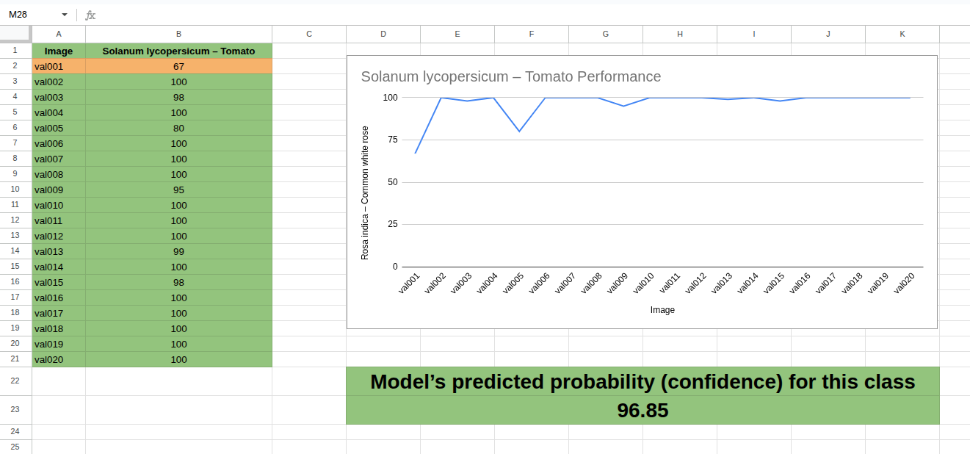

The Performance results folder contains the summarized analysis (Google Sheet) with model-predicted probabilities for each validation image.
The individual result images (tomato-val001_result.jpg to tomato-val020_result.jpg) display the top-5 predicted classes along with their confidence scores, providing a detailed visualization of the model’s predictions.

9.09 Performance of Triticum Aestivum – Wheat Plant Classification:
The average predicted probability (confidence) for this class is 89% on validation images that the model had not seen during training.
The detailed results and performance analysis are stored in the following locations:
Plants/
└── Validation result images/
└── Triticum Aestivum – Wheat Plant/
├── Performance results/
│ └── Performance of Triticum Aestivum – Wheat Plant Classification (Google Sheet)
├── wheat-plant-val001_result.jpg
├── wheat-plant-val002_result.jpg
├── wheat-plant-val003_result.jpg
├── ...
└── wheat-plant-val020_result.jpg

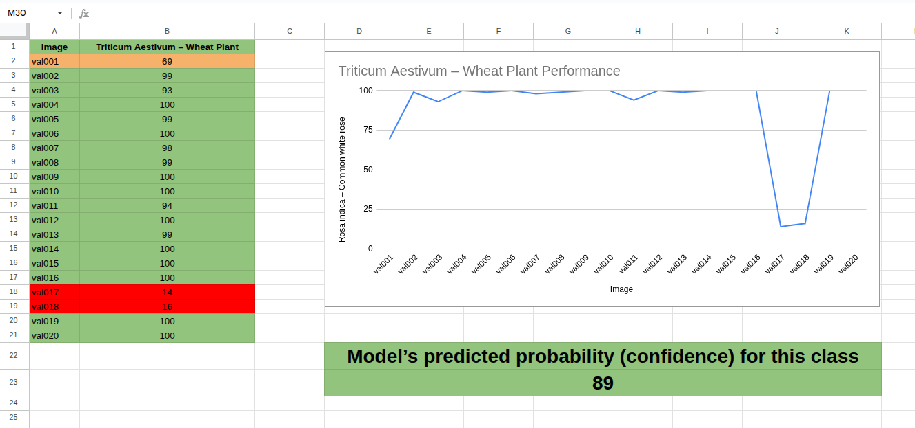

The Performance results folder contains the summarized analysis (Google Sheet) with model-predicted probabilities for each validation image.
The individual result images (wheat-plant-val001_result.jpg to wheat-plant-val001_result.jpg) display the top-5 predicted classes along with their confidence scores, providing a detailed visualization of the model’s predictions.

9.10 Performance of Zea mays – Maize (Corn) Classification:
The average predicted probability (confidence) for this class is 99.1% on validation images that the model had not seen during training.
The detailed results and performance analysis are stored in the following locations:
Plants/
└── Validation result images/
└── Zea mays – Maize (Corn)/
├── Performance results/
│ └── Performance of Zea mays – Maize (Corn) Classification (Google Sheet)
├── corn-val001_result.jpg
├── corn-val002_result.jpg
├── corn-val003_result.jpg
├── ...
└── corn-val020_result.jpg

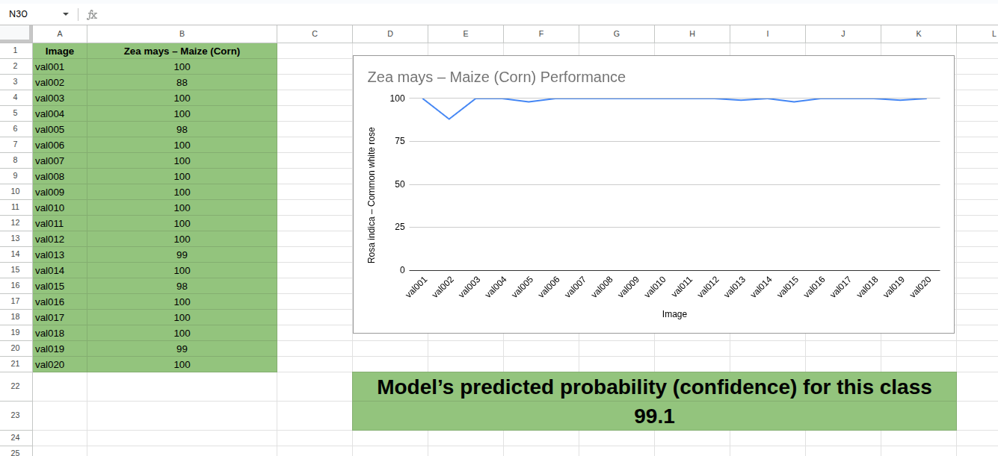

The Performance results folder contains the summarized analysis (Google Sheet) with model-predicted probabilities for each validation image.
The individual result images (corn-val001_result.jpg to corn-val020_result.jpg) display the top-5 predicted classes along with their confidence scores, providing a detailed visualization of the model’s predictions.

10. Model Weights and Inference:
During training, the YOLO classification model generates two key weight files:
runs/
└── classify/
└── train/
└── weights/
├── best.pt
└── last.pt

- best.pt → The weight file representing the best-performing model (based on validation performance).
- last.pt → The most recent model checkpoint, which can be used to resume or continue training in the future (e.g., if more dataset images are added).

10.1 Using the Model for Inference
You can load the trained model using best.pt and test it on any image (either downloaded from the internet or your own).
Make sure to install the latest version of Ultralytics before running inference:
!pip install --upgrade ultralytics
Example inference code:
from ultralytics import YOLO
# Load the trained model (update path to your best.pt)
model = YOLO('path to best.pt')
# Run inference on a new image (provide path to your test image)
results = model("path to the new image that you wish to classify")
# Display prediction results with top-5 classes and confidence scores
results[0].show()

10.2 Continuing Training:
If the dataset is expanded in the future, you can resume training from the last.pt checkpoint:
from ultralytics import YOLO
model = YOLO(' path to last.pt')
results = model.train(data='path to new dataset having same dataset organization', epochs=5 , imgsz= 416)

Conclusion
The Plants Classification Model trained using YOLO11n-cls has demonstrated excellent performance on both training and validation datasets. With an average Top-1 accuracy of 97.2% and a Top-5 accuracy of 100%, the model consistently identifies plant species with high reliability.
Validation images, which the model had never seen during training, were classified with high confidence, further confirming the model’s ability to generalize well to new, unseen data. Additionally, visual inspection of prediction results with confidence scores clearly supports its robustness.
This model can therefore serve as a reliable tool for automated plant classification and can be further enhanced by expanding the dataset or continuing training using the provided last.pt weights.

